*Florida International University*

*School of Computing and Information Sciences*

CIS 4911 - Senior Capstone Project

Software Engineering Focus

Feature Document

User Story #1008

**Team Member:**

Johnatan Jensen

**Product Owner(s)**:

Mohsen Taheri

**Mentor(s)**:

Mohsen Taheri

**Instructor**: Masoud Sadjadi

**User Story Notify users of successful project application**

* As a user I would like to be notified when my project application is submitted successfully

**Acceptance Criteria**

* Student project application notifies user of successful submission
* Proper administrative users receive email to approve or deny student

**Use Case**

1. **A PI or Faculty wants to be notified of a student's application to a project**   
   Participating Actors: Student, PI and/or Faculty  
     
   Entry Condition: Student fills out project application form  
     
   Events Flow:
2. Student submits his project application for his preferred project
3. PI or Faculty receive an email informing them they have a student wishing to apply for a project
4. PI or Faculty click on the link provided and are redirected to the review page
5. **Student after successful submission wants to be notified their application is submitted**   
   Participating Actors: Student  
     
   Entry Condition: Student submits project application  
     
   Events Flow:
6. Student presses submit button on project application form
7. Student sees a notification of successful submission

**Use Case Diagram**

**Sequence Diagram**

**Class Diagram**

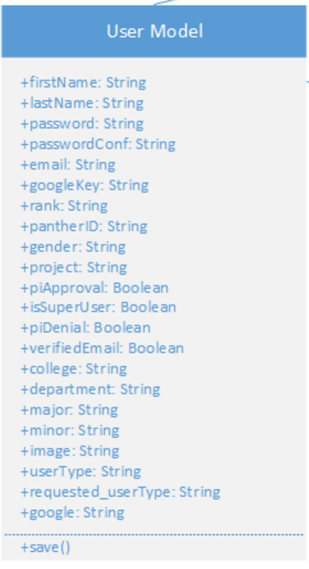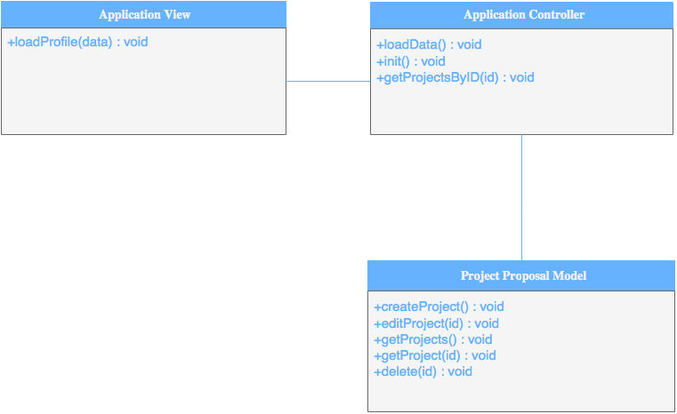

**Unit & Integration Tests**

* **Test Case 1**
  + **Purpose:**
  + **Precondition:**
  + **Expected Result:**
  + **Actual Result:** As expected
  + **Status: PASSED**

**Visual User Guide**